Flipped Classrooms and Microlearning  as a Tool for Success | AP Human Geography

The approaches and techniques explained are only intended to be a guide, and to enlighten you about the possibility of aligning a course utilizing asynchronous videos as an educational tool.

Why flip a classroom through microlearning?

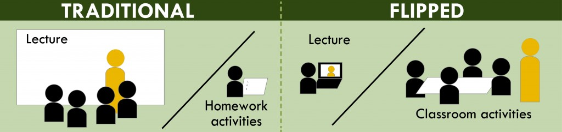
Source: http://www.washington.edu/teaching/files/2012/11/FlippedClassroomUWcolors-1-1024x242.jpg

- Microlearning is a way of teaching and delivering content to learners in small, very specific bursts. Utilizing videos, the instructor can flip the traditional experience of predominantly direct instruction, to predominantly refining skills and concepts during class time.
- It is asynchronous; the learners are in control of what and when they’re learning (some of the material).
- Speaks to the language of today’s students - who have grown up with Internet access, YouTube, Facebook, Snapchat, and a host of other digital resources. “Give the people want they want” – The Kinks.

Why NOT flip a classroom through microlearning?
- Because you think it will create a 21st-century classroom. Pedagogy should always drive technology, never the other way around.
- Because you think you will become cutting edge. Flipping does not necessarily use the latest technology.
- Because you think flipping your classroom exempts you from being a good teacher. Teaching is obviously much more than good content delivery.
- Because you think it will make your job easier. Flipping will NOT make your job any easier (in fact, it’s usually quite the opposite).

Critiques of the flipped classroom and microlearning:
- Many deride the flipped classroom approach because, honestly, many teachers are doing it wrong.
- If you can be replaced by a video, you should be.
- Videos students watch do not replace the teacher, they unleash the teacher.
- Many videos are utilized to present information beyond basic definitions and concepts.
- Videos are not necessary for every lesson, nor are they recommended for every lesson.

Importance of Class Time:
- Videos need to compliment the lesson plans set up for class time. A lesser-known fact is - the utilization of videos is not even the most important aspect of the flipped classroom.
- Again, the video does not relinquish the responsibility of the teacher to assess the level of student understanding.
- The lesson must emphasize the expectation for the students to display a progression of understanding. As the instructor, do not simply reiterate what was presented in the video.
- Removing a substantial amount of class time that would have been devoted to delivery of notes requires creativity on the part of the instructor to bring the class up to higher orders of thinking.

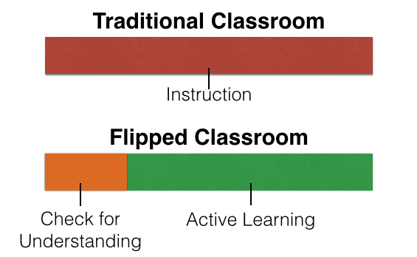
Source: http://blog.educanon.com/themes/pure/images/traditionalvsflipped.png
Getting Started:
- Two approaches – in front of the camera, or screen capture. Screen capture is generally much more effective for visually based social science courses such as geography.
- Write out a script for the dialogue. This may seem time consuming (and indeed it is), but this process will actually save time in the end by eliminating excessive errors while recording. Additionally, this step will help you organize your thoughts more clearly, and include all desired information.
- When creating scripts for video, a good rule of thumb to follow is 120 words for every minute of video. Making a short, content-rich video requires the ability to self-edit. If your scripting assets, take a good look at the content, and eliminate ALL the fluff. If your content is still longer than 4 minutes, you’re probably breaking the first commandment.
- Teach the students how to take notes with the videos. Use the first series of videos to deliver content and instruct how to record the information (hint – total dictation is really bad).
- Edutainment - know your audience. Better preparation replaces a time of drudgery to an engaging experience students look forward to.
- Make a video for your “Back to School Night”.

Construction of videos and lessons:
- Focus your objective(s). Teach no more than two learning objectives per video, but try to keep it to one.
- Grab their attention at the beginning. Present the learning objective(s) at the start of the video (what the learner will do or know after they complete the video). Often, an effective commencement of a video is to begin with the end in mind; hook the students by showing what they will know or be able to do by the end.
- Structure the video. Break the learning objective(s) into palatable and purposefully organized segments.
- Keep the video relatively short – no more than 8 minutes is preferable. The average attention span of the Millennial generation is 90 seconds (if that). Use rich imagery and direct language.
- Create lessons that prove learning took place. Instead of just asking them to answer a couple multiple choice questions, ask them to demonstrate their knowledge. Utilize class time for improvement and refinement of concepts and skills.
- Build assessments that compliment the flipped model. Utilize formative (authentic) assessments, as well as summative assessments.
- Stay true to your personality. This is true of any teacher and any teaching environment. To that end, students respond best when it is their own teacher’s voice.
- Plan ahead. Flipping the classroom is a long-distance race, and no teacher can expect to utilize videos for every lesson. Over time the instructor can add and refine videos. For example, adding videos within videos.

Technical Stuff:
- Production quality matters. It doesn’t take much to enhance your video quality without spending a lot of money. Suggested software includes Camtasia, Adobe Presenter, Snagit, Screenflo (Mac only). There are free options such as CamStudio (Windows only), however, remember - you usually get what you pay for.
- Create a YouTube channel (it’s easy: https://support.google.com/youtube/answer/1646861?hl=en). After you create your video, upload it to your channel). It is strongly recommended to create playlists within your channel for each unit, that way students can always find the right video. This is important, because when you upload a video it has a unique url address, and any changes will create an entirely new address (and therefore render any old hyperlinks useless).
- Check for completion. Utilize third party websites to upload your video and create quizzes. Recommended free sites are Zaption, Educanon, and EDpuzzle. These sites also usually allow you to create classes, so you can see who has watched the video – and who has not.

