Description: A student-created unit review using the three levels of questions
Rationale: Students will become better at answering questions if they become better at writing them
Time: 2 class periods
Materials: sticky notes, list of teacher-generated review topics

Day 1
- Introduce concept of the 3 levels of questions
  - Whole class practice with Cinderella or some other well-known content
  - Discuss these questions in relationship to your tests as well as the AP exam
    - Talk about obvious distractors on multiple choice questions
- Divide students into groups of 2-4
- Assign each group a review topic from the unit (topics can be as broad or specific as you like)
Example for unit 2: population pyramids, historical trends in migration, Demographic Transition Model, remittances, Syrian refugees
- Each group will write a total of 4 questions
  - (1) level 1 MCQ, (2) level 2 MCQ, (1) level 3 question
    - This takes 1 class period for most students
    - Teacher approval before students can write their questions on sticky notes
  - Approved questions get written on a sticky note with question and answer choices (if applicable) on the front and answer on the back
- Place the sticky notes on the classroom walls grouping questions by question type
  - Add questions from students in other classes as the school day progresses
Day 2
- Students can do a self-paced walkabout using the questions posted on the walls
  - If you’re concerned about keeping them focused you can require that kids attempt a specific number of questions
  - Kids can create their own study guide by tracking which topic they miss the most questions on
- Debrief class about experience (10-15 mins for the first time using the strategy)
  - Which questions were the easiest to write/answer? Why?
  - Which questions were the hardest to write/answer? Why?
  - What did they think about the process?
  - How will this change how they study?
  - Would you study differently for a test composed of level 1 questions vs. level 2 questions?

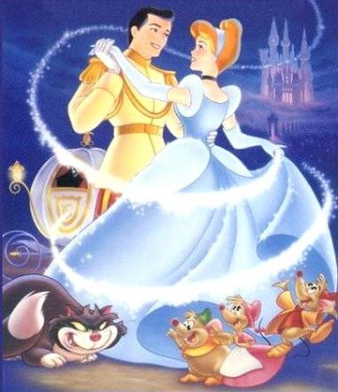
Level I: Recall
The answer is in the text; explicit, fact
(fully and clearly expressed; leaving nothing implied)
What were Cinderella's slippers made out of?
How did Cinderella get to the ball?

Level II: Analysis/Inference
(The act or process of deriving logical conclusions from premises known or assumed to be true) Implicit or what is implied; analysis, ask how and why, require analysis of the text, reading between the lines, hidden meaning. (understood though not directly expressed)
Why does Cinderella's stepmother care whether or not she goes to the ball?
Why did everything turn back the way it was except the glass slipper?
Why don't the step sisters like Cinderella?

Level III: Synthesis
Go beyond the text and inquire into the value, importance and application of the information presented.
Does a woman's salvation always lie with a man?
What does it mean to live happily ever after?
Does good always overcome evil?

